Hyphenated Compound Word

🔹 What is Hyphenated Compounds word
# Source: AI Source: Provided by: [Data Path: Persons Table -> ID Column: 1, Name_En Column: Motasem Essam] -> From: [Chatgpt (GPT-4-turbo)] on [7/25/2025]
A hyphenated compound word is a compound word where the parts are connected by one or more hyphens ( - ).

✅ Definition:
# Source: AI Source: Provided by: [Data Path: Persons Table -> ID Column: 1, Name_En Column: Motasem Essam] -> From: [Chatgpt (GPT-4-turbo)] on [7/25/2025]
A hyphenated compound is formed by joining two or more words with hyphens to create a single unit of meaning. The hyphen helps show that the words work together as one.

What is a Hyphen?
# Source: AI Source: Provided by: [Data Path: Persons Table -> ID Column: 1, Name_En Column: Motasem Essam] -> From: [Chatgpt (GPT-4-turbo)] on [7/25/2025]
A hyphen is a punctuation mark: “-” (short dash)
It is used to connect words or parts of words.

✅ Common Uses of Hyphens:
# Source: AI Source: Provided by: [Data Path: Persons Table -> ID Column: 1, Name_En Column: Motasem Essam] -> From: [Chatgpt (GPT-4-turbo)] on [7/25/2025]
- Compound Words
🔹 To join words together to form a compound word:
  - mother-in-law
  - well-known
  - part-time
- Word Breaks at Line Endings
🔹 When a word is too long to fit at the end of a line:
  - "The students were study-
ing hard for their exams."
- Prefixes before Proper Nouns or Similar Words
🔹 To separate a prefix from a capitalized word:
  - ex-President
  - anti-American
- Avoiding Ambiguity
🔹 To make the meaning clearer:
  - re-sign (sign again) vs. resign (quit a job)
- Spelled-Out Numbers
🔹 In compound numbers from 21 to 99:
  - twenty-one
  - eighty-five

❌ Not a Hyphen:
# Source: AI Source: Provided by: [Data Path: Persons Table -> ID Column: 1, Name_En Column: Motasem Essam] -> From: [Chatgpt (GPT-4-turbo)] on [7/25/2025]
- A hyphen is not the same as a dash (– or —), which is longer and used for different purposes (like separating clauses).

Quick Summary:
# Source: AI Source: Provided by: [Data Path: Persons Table -> ID Column: 1, Name_En Column: Motasem Essam] -> From: [Chatgpt (GPT-4-turbo)] on [7/25/2025]
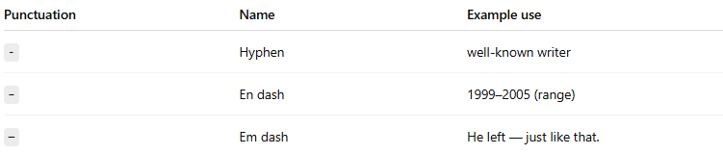
Punctuation | Name | Example use
- | Hyphen | well-known writer
– | En dash | 1999–2005 (range)
— | Em dash | He left — just like that.

🔸 Examples of Hyphenated Compound Words:
# Source: AI Source: Provided by: [Data Path: Persons Table -> ID Column: 1, Name_En Column: Motasem Essam] -> From: [Chatgpt (GPT-4-turbo)] on [7/25/2025]
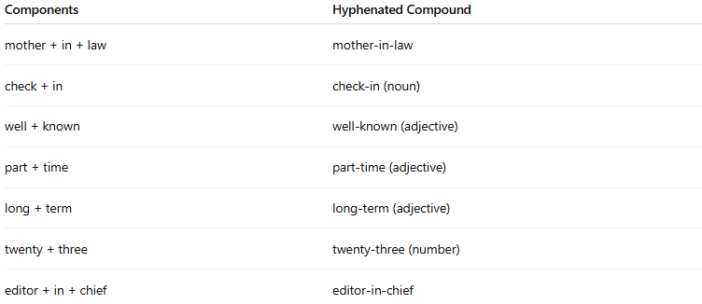
Components | Hyphenated Compound
mother + in + law | mother-in-law
check + in | check-in (noun)
well + known | well-known (adjective)
part + time | part-time (adjective)
long + term | long-term (adjective)
twenty + three | twenty-three (number)
editor + in + chief | editor-in-chief

🧠 Usage Notes:
# Source: AI Source: Provided by: [Data Path: Persons Table -> ID Column: 1, Name_En Column: Motasem Essam] -> From: [Chatgpt (GPT-4-turbo)] on [7/25/2025]
- Hyphenation is often used to avoid confusion or to clarify meaning.
- Common in:
  - Compound adjectives before nouns
e.g., a well-known author, a part-time job
  - Compound nouns with specific roles or meanings
e.g., sister-in-law, runner-up
- Some hyphenated compounds may become closed over time.
  - e-mail → email, on-line → online

🆚 Other Types of Compound Words:
# Source: AI Source: Provided by: [Data Path: Persons Table -> ID Column: 1, Name_En Column: Motasem Essam] -> From: [Chatgpt (GPT-4-turbo)] on [7/25/2025]
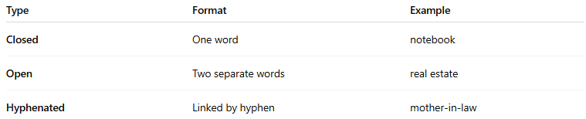
Type | Format | Example
Closed | One word | notebook
Open | Two separate words | real estate
Hyphenated | Linked by hyphen | mother-in-law

📌 Summary:
# Source: AI Source: Provided by: [Data Path: Persons Table -> ID Column: 1, Name_En Column: Motasem Essam] -> From: [Chatgpt (GPT-4-turbo)] on [7/25/2025]
- Hyphenated compound words use hyphens to link two or more words into a single meaning.
- They are common in adjectives, nouns, and numbers.
- Proper hyphenation is important for clarity and grammar.

